FINGERPRINT SCHEDULING & ADMINSTRATIVE PAYMENT INSTRUCTIONS
You are required to schedule two (2) fingerprint appointments. One with the Department of Education (DOE) and the second with the Division of Developmental Disabilities (DDD).
Note: It is best to use a computer when settings up your fingerprint appointments.

Department of Education (DOE) Fingerprint Steps
Please note: There is an $11 fee associated with scheduling this fingerprint appointment and a secondary fee at the time of your fingerprint appointment. You will be reimbursed for the fees after your internship begins.
- Access the DOE fingerprint payment authorization website at: https://nj.gov/education/crimhist/index.shtml
- Click on, “File Authorization and Make Electronic Payment.”
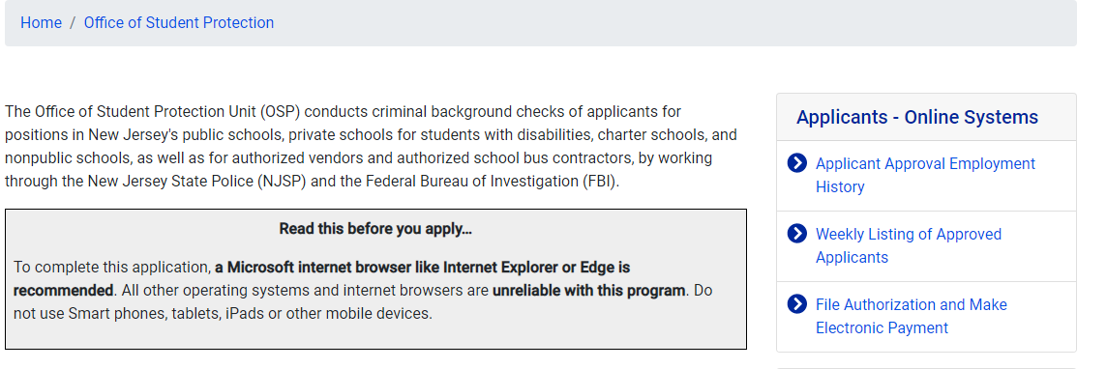

- Select Option #1: New Administration Fee Request (New Applicants Only)

Enter your Social Security Number, then click Continue 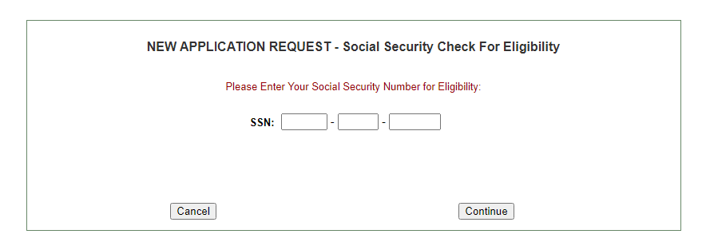

- Select Option #1: “All Job Positions, except School Bus Drivers and Bus Aides, for Public Schools, Private Schools for Children with Disabilities and Charter Schools”

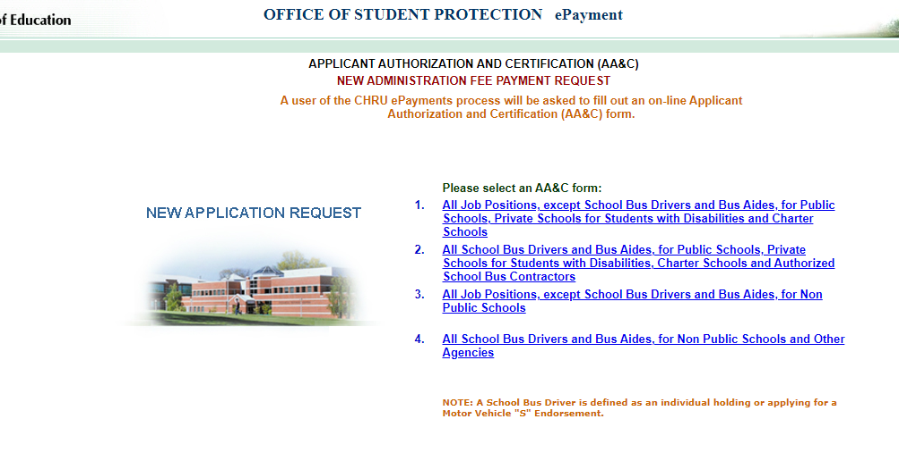

- Complete the requested applicant information.

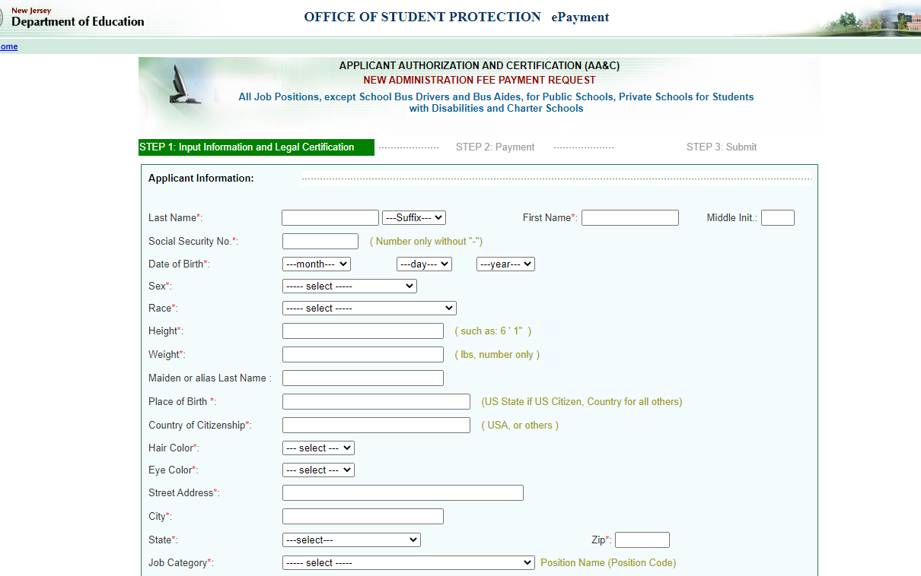

Job Category*: Code 17- Volunteers

Select “Other School Selection”
        - County – “Somerset (36)”
        - District – “Somerset Hills Regional (8274)”
        - School – “Matheny School (001)”

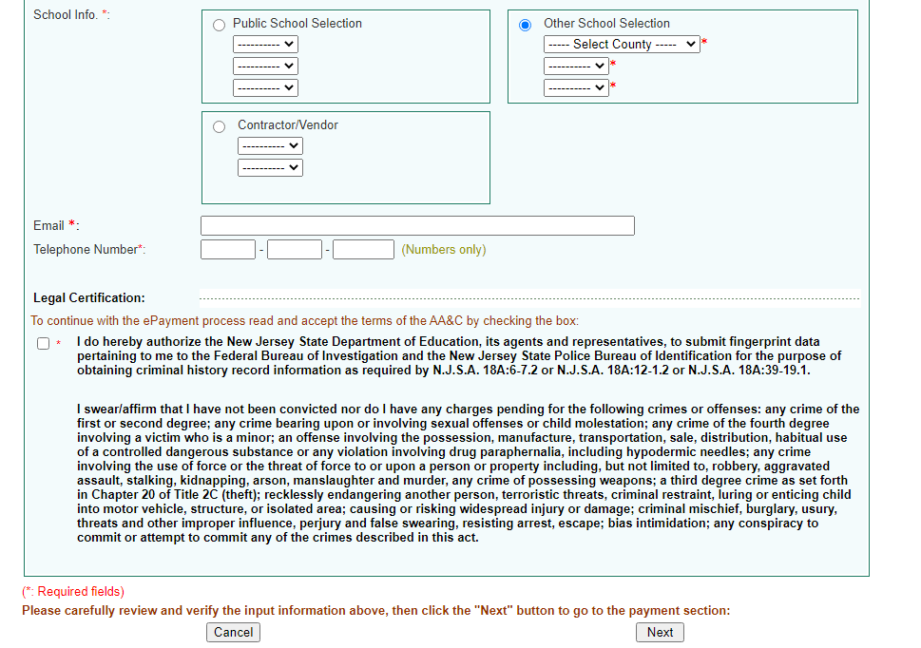

Enter your Email address and Telephone number and proceed to the Legal Certification. In order to continue with the ePayment process, read and accept the terms of the Applicant Authorization & Certification form by checking the box. Then click “Next”

- Complete the payment information, click “Make a Payment,” and then click Next.
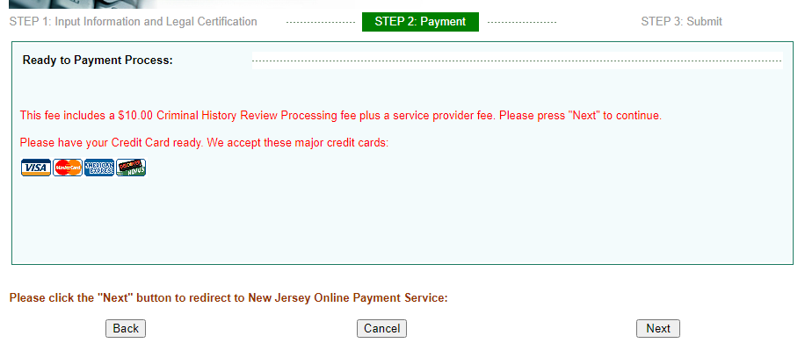
- After completing the transaction, you will be presented with three (3) required steps:

- View and/or print your New Administration Fee Payment Request confirmation page
Select the first option “View and/or print your New Administration Fee Payment Request confirmation page” and print a copy of the receipt by clicking the print button in the upper right corner of the page and present a copy to the employing entity.

- View and/or print your IdentoGO NJ Universal Fingerprint Form
Next select the second option “View and/or print your IdentoGO NJ Universal Fingerprint Form.” You must print the IdentoGO NJ Fingerprint Form to use when making your fingerprint appointment and to present it to IdentoGO at the time of fingerprinting.

- Click here to schedule your fingerprinting appointment with IdentoGo
Click the link. This will bring you to the IdentoGO website at https://uenroll.identogo.com/
Use the data below to make a fingerprinting appointment with the Department of Education (DOE)
    - Service Code: 2F1FB1
    - Contributor Case#: 368274001

Division of Developmental Disabilities (DDD) Fingerprint Steps
- Using the same website, https://uenroll.identogo.com, use the data below to make a fingerprinting appointment with the DDD (Human Services Private Contractor):
    - Service Code: 2F16S7
    - Contributor Case#: PC1111

*Upon completion, please notify Kelly Walsh, H.R. Human Resource Business Partner at kwalsh@matheny.org or call 908-234-0011 ext. 1321 to notify her with the dates for your scheduled appointments.

